Gem5 Hello World
- My git account is - https://github.com/gdd-shobhit/UCAssignments/tree/main/Computer%20Architecture
Simulation result – Hello world
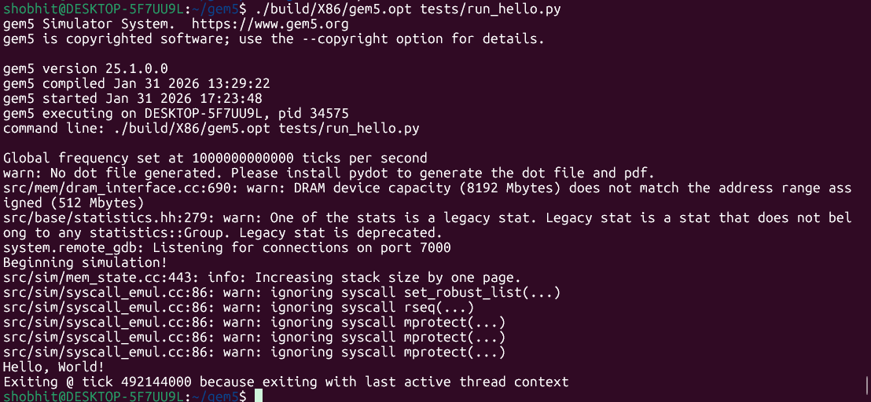
Issues and obstacles that occurred
- Again, this assignment also started with insane confusion. The run_hello.py is not compatible with Gem 5 - 25.xx > versions, which you get when you get the latest on gem5. Since we are building it ourselves, we cannot use pre-built binaries, which is fine.
- The compatibility issue becomes bigger as se.py, which we are using to run the program, is fully deprecated, so we cannot use ./build/X86/gem5.opt configs/example/se.py -c hello
  - Moreover, if we use se.py to run our compiled hello program, then why are we creating a run_hello.py? It didn’t make sense.
- After some research, it made sense that maybe we have to rewrite the run_hello.py to make the hello program run since se.py is deprecated.
  - I had to go research how to run compiled C programs in an x86 memory board and what membus, sideports, connectors, etc, are, as the run_hello.py code provided actually does not work.
  - I had to add a process, connect the ports through side ports, L1 cache definitions do not exist in the m5 library, so I had to declare my own cache and then connect it in the memory board. It was a whole research project to figure out what was wrong with run_hello.py
- At the end, after fixing all the problems in that py file, I ran ./build/X86/gem5.opt tests/run_hello.py which then printed hello world.
Observations
- Deprecated code was hard to find and figure out what is the correct new way to do it. Gem5 didn’t provide a new se.py file to run compiled programs. Although, this gave me an idea of what I had to change and how membus acts, what connects to what and what the simulation is requiring me to do and learn

I have uploaded my .py files on github to look at

